Filtering Posts in the Discussions Tool – D2L Tutorial
This tutorial is designed for faculty who have previous experience using the Discussions tool. For further information, please contact elearning@camosun.ca for assistance.

Scenario
This tutorial will cover the steps involved when you wish to view discussion postings within a Topic using specific filters in a Discussion Topic.

Steps
- Go to the Discussions tool in your course.
- Click on the title of the Topic you want to view.
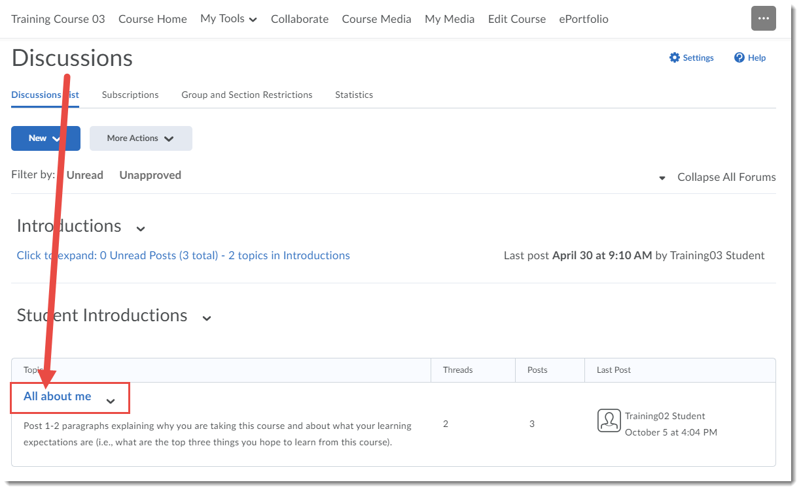

- You can Filter by Unread or Flagged Threads …
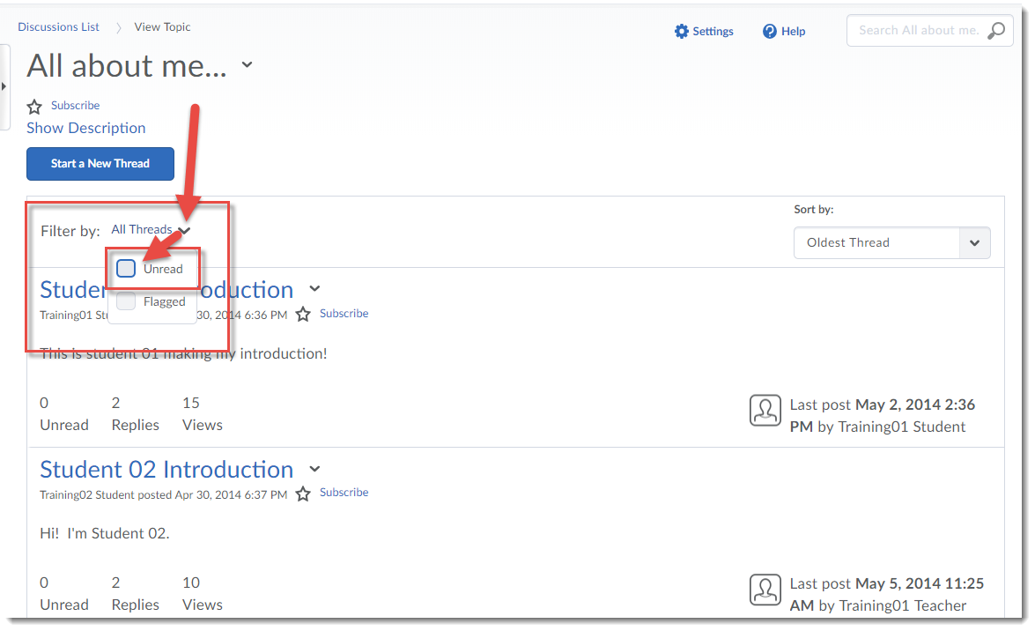
- Or you can click the Sort By drop-down menu to view threads in this Topic by Most Recent Activity, Least Recent Activity, Newest Thread, Oldest Thread, Author First Name A-Z, Author First Name Z-A, Author Last Name A-Z, Author Last Name Z-A, Subject A-Z, Subject Z-A.
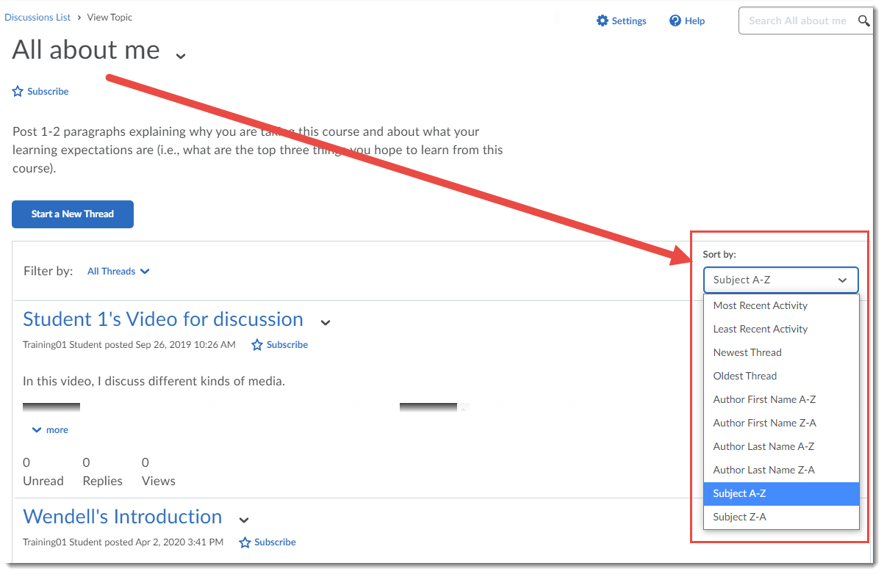

- You can also search for specific key words by typing them into the Search box at the top right, and clicking the magnifying glass.
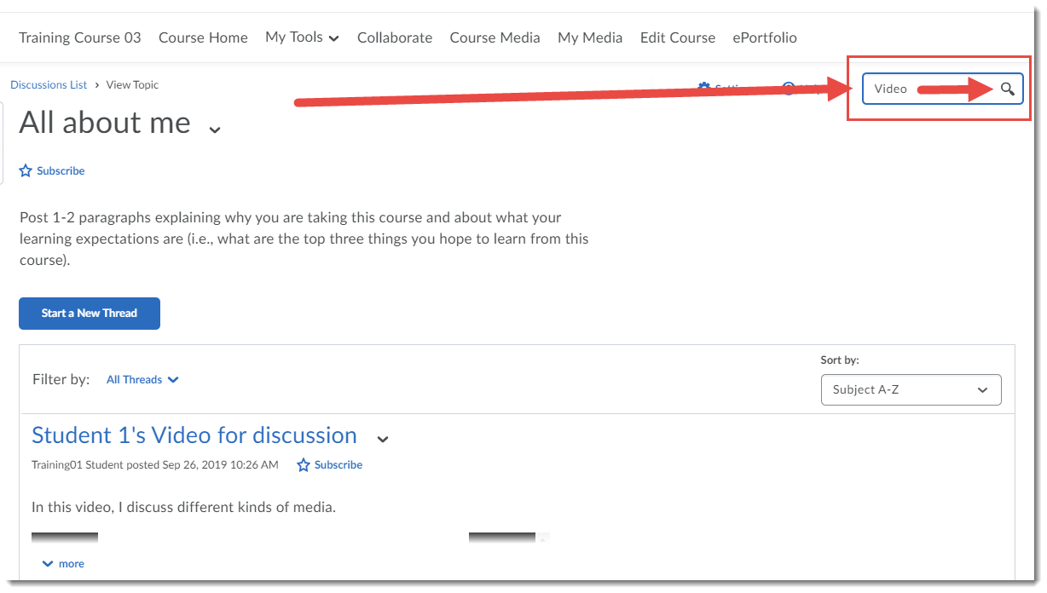

Things to Remember
While your filter choices (Unread or Flagged) will not be “remembered” the next time you go into the Topic you filtered, your last choice in the Sort by menu will be, so you may need to adjust that next time you go into the Topic.

